컴퓨터프로그래밍II (COSE102)
2015, fall, finals - C

- 다음에 대하여 간략히 설명하여 보시오. (총 10점)
Explain the following argument. (total 10 points)
- 클래스와 객체에 대해 예를 들어 설명하시오 (2점)
about Class and Object (Explain with an example) (2 points)
- 객체지향 프로그래밍을 사용하는 이유 (3점)
Reason for using Object Oriented Programming (3 points)
- Abstract class와 interface의 차이점 (3점)
difference between override and overloading (3 points)
- getter와 setter를 사용하는 이유. (예제를 통해 설명) (2점)
Reason for using ‘getter’ and ‘setter’ keyword. (Explain with example) (2 points)

- 다음 코드의 실행 결과를 적으시오. 만약 실행이 되지 않는다면 그 이유를 설명하시오. (8점)
Given the following code: What is the output from an execution of this code? If this code doesn't work, then explain the reason why. (8 points)
public class Faculty extends Employee {
public static void main(String[] args) {
new Faculty();
}
}

class Employee extends Person {
public Employee() {
this("");
System.out.println("A");
}

public Employee(String s) {
super("");
System.out.println("B");
}
}

class Person {
public Person() {
System.out.println("C");
}

public Person(String s) {
this();
System.out.println("D");
}
}

- 다음 코드의 실행 결과를 적으시오. 만약 실행이 되지 않는다면 그 이유를 설명하시오. (8점)
Given the following code: What is the output from an execution of this code? If this code doesn't work, then explain the reason why. (8 points)
class Main {
public static void main(String[] args) {
String x = (String)new Object();
x = "3";
System.out.println(x.toString());
}
}

- 다음 코드의 실행 결과를 적으시오. 만약 실행이 되지 않는다면 그 이유를 설명하시오. (8점)
Given the following code: What is the output from an execution of this code? If this code doesn't work, then explain the reason why. (8 points)
public class Main {
static int i = 0;
static int j = 0;

public static void main(String[] args) {
int i = 2;
int k = 0;
{
int j = 3;
System.out.println("ij is " + i + j);
}
k = i + j;
System.out.println("k is " + k);
System.out.println("j is " + j);
}
}

- 다음 코드의 실행 결과를 적으시오. 만약 실행이 되지 않는다면 그 이유를 설명하시오. (8점)
Given the following code: What is the output from an execution of this code? If this code doesn't work, then explain the reason why. (8 points)
class Main {
public static void main(String[] args) {
A a = new A("Hello World");
a.print();
}
}

class A {
String s;

public void print() {
System.out.print(s);
}
}
- 다음 코드의 실행 결과를 적으시오. 만약 실행이 되지 않는다면 그 이유를 설명하시오. (8점)
Given the following code: What is the output from an execution of this code? If this code doesn't work, then explain the reason why. (8 points)
import java.util.*;
public class Main {
public static void main(String[] args) {
Date d1 = new Date();
Date d2 = (Date)d1.clone();
Date d3 = d1;
System.out.println("A: " + (d1 == d2));
System.out.println("B: " + (d1 == d3));
System.out.println("C: " + d1.equals(d2));
System.out.println("D: " + d1.equals(d3));
}
}

- 다음 코드의 실행 결과를 적으시오. 만약 실행이 되지 않는다면 그 이유를 설명하시오. (8점)
Given the following code: What is the output from an execution of this code? If this code doesn't work, then explain the reason why. (8 points)
public class Main {
private String x1;
public String x2;
String x3;
protected String x4;

public static void main(String[] args) {
Main foo = new Main();
System.out.println(foo.x1);
System.out.println(foo.x2);
System.out.println(foo.x3);
System.out.println(foo.x4);
}
}

- 다음 코드의 실행 결과를 적으시오. 만약 실행이 되지 않는다면 그 이유를 설명하시오. (8점)
Given the following code: What is the output from an execution of this code? If this code doesn't work, then explain the reason why. (8 points)
public class Main {
public static void main(String[] args) {
String s = "92plflm24belj".replaceAll("[3-9p]+", "X");
System.out.println(s);
}
}

- 다음 코드의 실행 결과를 적으시오. 만약 실행이 되지 않는다면 그 이유를 설명하시오. (8점)
Given the following code: What is the output from an execution of this code? If this code doesn't work, then explain the reason why. (8 points)
public class Main {
private int Sum(int a, int b) {
return a + b;
}
public static void main(String[] args) {
System.out.println(Sum(+1+1,-1-1));
}
}

- 다음 코드의 run1 함수에서 발생하는 모든 exception을 처리하도록 A와 B영역의 코드를 작성하시오. (A영역에는 복수의 catch 구문이 위치함) (8점)
given the following code: write a code for section A and B so that it can handle all the exception that may occur in function run1. (8 points)
import java.io.FileNotFoundException;
import java.util.Date;

public class Main {
public static void main(String[] args) {
try {
new Main().run1();
}
_________ A ___________

}

void run1() _________ B ___________ {
long rand = new Date().getTime() % 4;
if (rand == 0) throw new ClassNotFoundException1();
if (rand == 1) throw new ClassNotFoundException2();
if (rand == 2) throw new RuntimeException();
throw new NullPointerException();
}
}

class ClassNotFoundException1 extends ClassNotFoundException {
}

class ClassNotFoundException2 extends ClassNotFoundException1 {
}

- 다음 그림과 요구사항을 참고하여 개체 유형 별 class를 설계하시오. (10점)
Given the following figure and requirements, design a class for each type of object. (10 points)
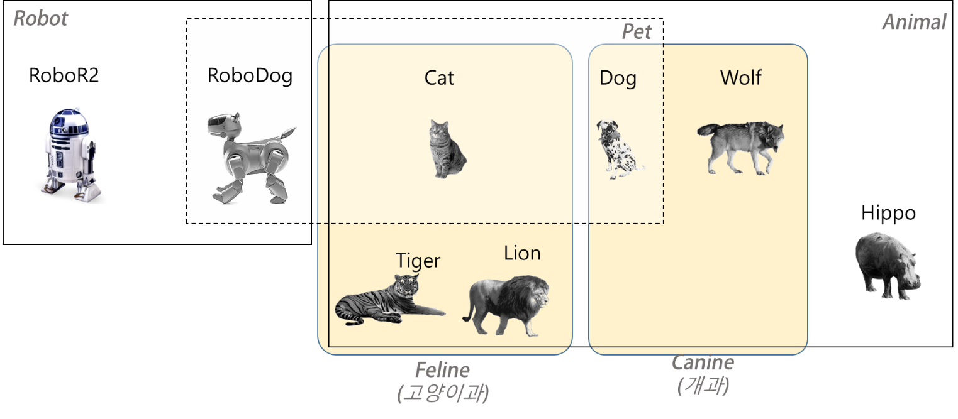
요구사항.

- Class를 설계할 때 추상 클래스(abstract class), 인터페이스(interface)와 상속(inheritance)을 사용해야 함.
- Class를 기술할 때 선언부(class declaration), 생성자(constructor), 속성(data fields)은 필수이며, method는 생략 가능함.
- RoboDog, Cat, Dog은 Pet의 instance이다.

Requirements

- Interface and inheritance must be used when designing a class.
- A class should include class declaration, constructor, and data fields (description of methods are not necessary)
- RoboDog, Cat and Dog are instances of Pet

- 다음 코드의 실행결과가 나오도록 Person과 Name 클래스의 코드를 작성하시오. (8점)
Given the following code: write a code for ‘Person’ class and ‘Name’ class so it can output the result below (8 points)
코드 (code)
import java.util.ArrayList;
import java.util.Collections;

public class Main {
public static void main(String[] args) throws CloneNotSupportedException {

ArrayList<Person> persons = new ArrayList<>();
persons.add(new Person(new Name("F1", "L1"), "A1"));
persons.add(new Person(new Name("F2", "L3"), "A2"));
persons.add(new Person(new Name("F3", "L3"), "A3"));
persons.add(new Person(new Name("F4", "L2"), "A4"));

Collections.sort(persons);
System.out.println(persons);

Person p1 = new Person(new Name("F0", "L0"), "A0");
Person p2 = (Person)p1.clone();
p1.name.firstName = "F-";

System.out.println(p1);
System.out.println(p2);
}
}
실행 결과 (output)
[L1 F1 : A1, L2 F4 : A4, L3 F2 : A2, L3 F3 : A3]
L0 F- : A0
L0 F0 : A0

